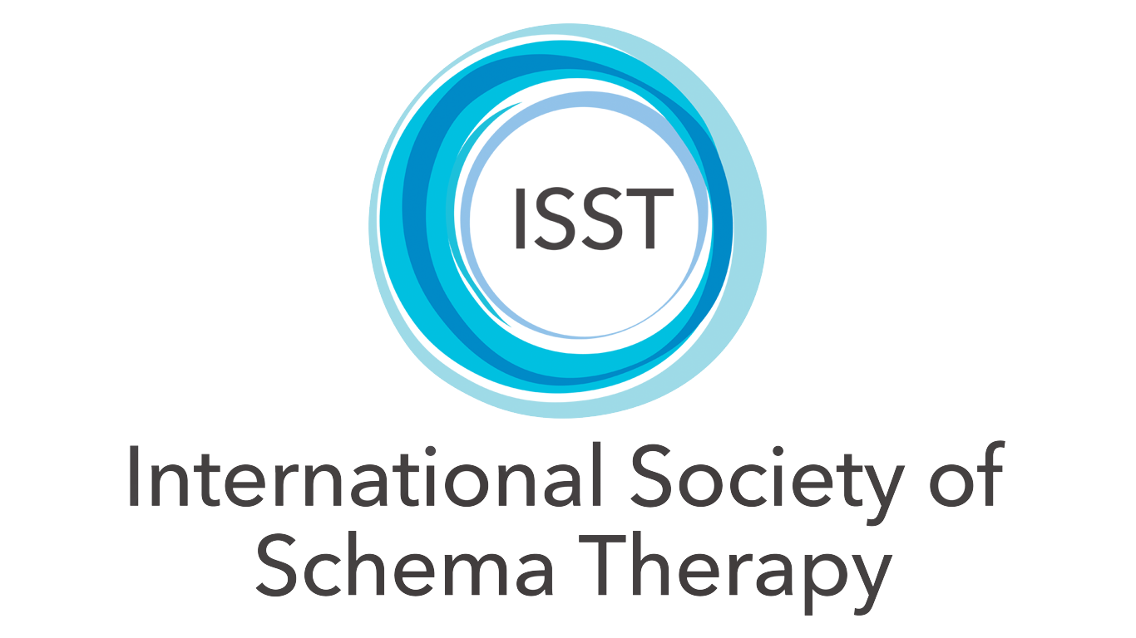

CONSENT TO RECORD VIDEO/AUDIO SCHEMA THERAPY SESSION

PLEASE READ ALL OF THE BELOW INFORMATION CAREFULLY.

As part of the ongoing professional development requirements set out by the ISST therapists who are undergoing intense ST training must have supervision with other therapists on a regular basis. This can be both with an individual, or in a group setting. As part of this process recordings of sessions are encouraged to promote learning and provide competency in ST, this allows for quality assurance and integrity to the therapeutic model.

By signing this form, you consent to your session(s) being recorded and understand the following:

1. My therapist will ask for my permission before recording any session

2. I can ask that the recording and all copies of the recording be deleted at any time

3. My therapist will only use the recording for the purposes of professional supervision/certification in ST with other therapists and, will not share the recording for any other purpose.

4. I understand my therapist will follow the privacy laws and code of ethics that are specific to our country of origin.

5. All copies of the recording will be deleted after 90 days of the recording taking place.

Please sign this form if you understand and consent to the above. Your consent can be revoked at any time by contacting your therapist directly.

Client Name: ____________________

Client Signature: _________________

Date:____________________________

